BNC Input/Output boxes for SIBS 353 Chart Recorder Program
John Dempster 11/6/7

BNC input/output boxes for connecting signals to A/D converter and external trigger inputs and supplies outputs from D/A converter and one digital output of National Instruments PCI-6621 interface card.

Use existing boxes from SIBS 353 but replace 50 way ribbon cable with 37 way ribbon, 1.5 metre long, connected to 37 way D type female socket.

36 I/O boxes need to be converted, required by first week in September.

Please check with me after first one is wired.

Panel layout and labelling

ADC0
ADC1
ADC2
ADC3
DAC0
DAC1
DIG0
EXT TRIG
37 way D type socket (female)
37 way ribbon cable
1.5 Metre long

Pin connections

BNC socket | Pin |  | Ribbon cable wire | 37 way D type pin
ADC0 | Sig | → | 1 | 1 (AI0)
ADC1 | Sig | → | 4 | 21 (AI1)
ADC2 | Sig | → | 6 | 22 (A12)
ADC3 | Sig | → | 9 | 5 (AI3)
ADC0+1+2+3 | Ground | → | 15 + 10 | 8 (AI SENSE) + 24 (AIGND)
DAC 0 | Sig | ← | 23 | 12 (AO0)
DAC 1 | Sig | ← | 22 | 30 (AO1)
DAC0+1 | Ground | ← | 21 | 11 (AOGND)
BNC DIG 0 | Sig. | ← | 36 | 37 (P0.0)
EXT TRIGGER | Sig | → | 25 | 13 (PFI0/P1.0)
DIG0 +  EXT TRIGGER | Ground | → | 27 | 14 (DGND)

Pin out of 37 way D type connector on PCI-6221 card.
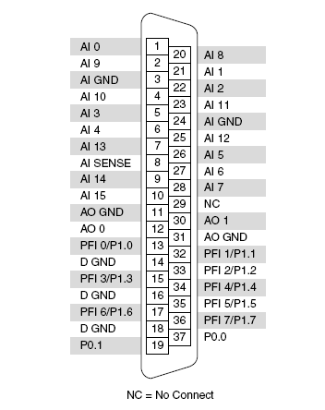

Parts

RS #
409-3270 | 37 way IDC plastic body D socket | 36 | 36 x £7.30 = £262.80
359-992 | Speedbloc(R) 37 way IDC ribbon cable,30m | 2 | 2 x £73.25 = £146.50

Charge cost to 12100 VA5300C

